# Home Objects detection using Mask RCNN

[Mask RCNN](https://arxiv.org/pdf/1703.06870.pdf) is a supervised deep neural network to detect, localize and pixelwise segment the objects in an image by Kaiming He’s team at Facebook.

In this project, Matterport’s implementation [1] is used. I created a sample application called home_object, which is stored in Root_dir/samples/home_object. The dataset and it’s annotation are stored in Root_dir/datasets/home_object.

Implementation

The python code for this project can be accessed from my Github repository [3].

Home_object.py: containing the training and test script, over-written class of HomeObject. It is a modified version from balloon.

Inspect_home_object_data.ipynb: checking dataset and annotations

Inspect_homeobject_model.py: checking trained model (for unknow reason, inspect_homeobject_model.ipynb does not work)

Check_bounday.py: checking bounding box annotation from downloaded dataset

Rewrite_images.py: read and re-create the jpeg images. Original jpeg files contain tags, such as ‘orientation’ used by the annotation tools. This cause the annotation tool to open the images and rotate the images according to orientation in the tag, which cause inconsistency of annotation data. Recreating the images will remove all the tags from original images.

Annotation Tool

In this project, we use VIA (VGG Image Annotator) [2] because of its simplicity.

Loss Functions

This implementation uses five loss functions:

rpn_class_loss: calculated as the categorical_crossentropy of targe anchor class and RPN output.

Rpn_bbox_loss: smooth_l1_loss of target bounding box and RPN output bounding box

Mrcnn_class_loss: softmax_cross_entropy of target object classes and predicted classes

Mrcnn_bbox_loss: trucked smooth_11_loss of target bounding boxes and predicted bounding boxes.

Mrcnn_mask_loss: cumulated binary_crossentropy loss of pixelwise target object mask and the predicted mask

The total loss is the sum of averaged loss in all the above categories. For the loss of classification, this implementation uses either binary cross entropy (for two class, such as object or background), or categorical cross entropy (for multi-classes). For regression loss, this implementation uses smoothed L1 loss instead of L2 loss. This has the advantage of less sensitive to outliers.

One improvement we can try is to incorporate the weights for different classes into the loss function. This can avoid the loss function being dominated by majority class (like ‘bottle’ class in our dataset).

Optimizers

The original implementation uses SGD optimizer in keras. We tried both SGD and adam optimizer. Both optimizes works similar. But when it is close to 30 epochs in training, Adam has more oscillation.

Image Augmentation

Because only a small training dataset (about 100 images) is available, it is not enough to train even the head layers. The best way to ameliorate the problem is to augment the dataset. Image augmentation artificially creates training images through different ways of processing or combination of multiple processing, such as random rotation, shifts, shear and flips, etc.

For this project, I did not use off-line augmentation mainly because of time limit. It takes lots of time to annotate the augmented images.

During training, imgaug library is used to augment the training images on-the-fly, because the annotation data can be changed on-the-fly the same as the augmented images.

Training

We train the neural network by freezing all the layers except the head layers. We downloaded the pretrained network, which use backbone network of ResNet50. We are not sure about the quality of this trained model, because we found this in the comment of Matterport’s implementation. Matterport only provided a pretrained network with backbone of ResNet101.

In the first phase, SGD optimizer was used, and no image augmentation was used. We train the model for 30 epochs. The loss is decreased almost continuously, but the trained model can not detect objects. I am using my laptop to do the training, and each train takes about a day. For unknown reason, my laptop GPU does not work for this model, even though I reinstalled CUDA driver and cudnn library and downgrade my keras from latest version of 1.14.0 to 1.12, according to some guide found on web.

In second round, I used Adam optimizer instead of SGD, with imgaug library for on-the-fly data augmentation. The trained model can detect some objects. Figure 1 is an example.

I tried to start an AWS EC2 instance to the training, but later gave up because I need to install all the software myself.

In the third round, instead of retrain all the head layers from scratch, I start the training using the trained parameters of mrcc_bbox layers from the trained model of mask_rcnn_coco_2.h5. The training is still going on.

Figure 2-7 are the learning curve of the losses. From the curves, we can see the training loss is almost always decreased with with epochs. But training does not help validation loss in mrcc_mask_loss, rpn_bbox_loss, and rpn_class_loss. This means more training does not help to detect the object better and the region proposal better. These two factors are actually correlated. If you can not find the region of the object better, you will not be able to find the boundary of the object. Main reason for this is that the training dataset is mostly single object in each image. But in validation dataset, most images have several objects in them, and some parts of the object are often occuluded. This make the detection of the object mask much harder.

Overall, in current project, we don’t have enough training images to retrain the head layers.

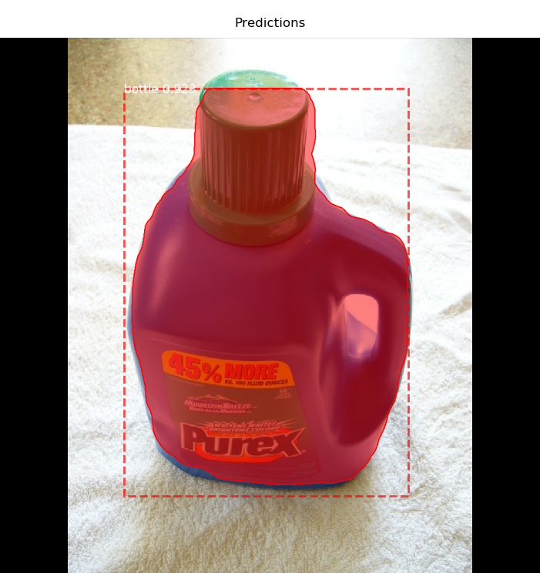

Figure 1. Object detection. The reddish colored part is the prediction of the object mask

Figure 2. Learning curve of total loss

Figure 3 Learning curve of mrcnn_bbox_loss

Figure 4. Learning curve of mrcnn_class_loss

Figure 5. Learning curve mrcnn_mask_loss

Figure 6. Learning curve of rpn_bbox_loss

Figure 7. Learning curve of rpn_class_loss

[1] Matterrport, <https://github.com/matterport/Mask_RCNN>

[2] VIA annotation tool, <http://www.robots.ox.ac.uk/~vgg/software/via/>

[3] My implementation, , https://github.com/pingdong2017/Mask_RCNN